- Aim: Class Diagram for Atm
Class diagrams describe the static structure of a system, or how it is structured rather than how it behaves.

These diagrams contain the following elements:

- Classes, which represent entities with common characteristics or features. These features include attributes, operations, and associations.

- Associations, which represent relationships that relate two or more other classes where the relationships have common characteristics or features. These features include attributes and operations.
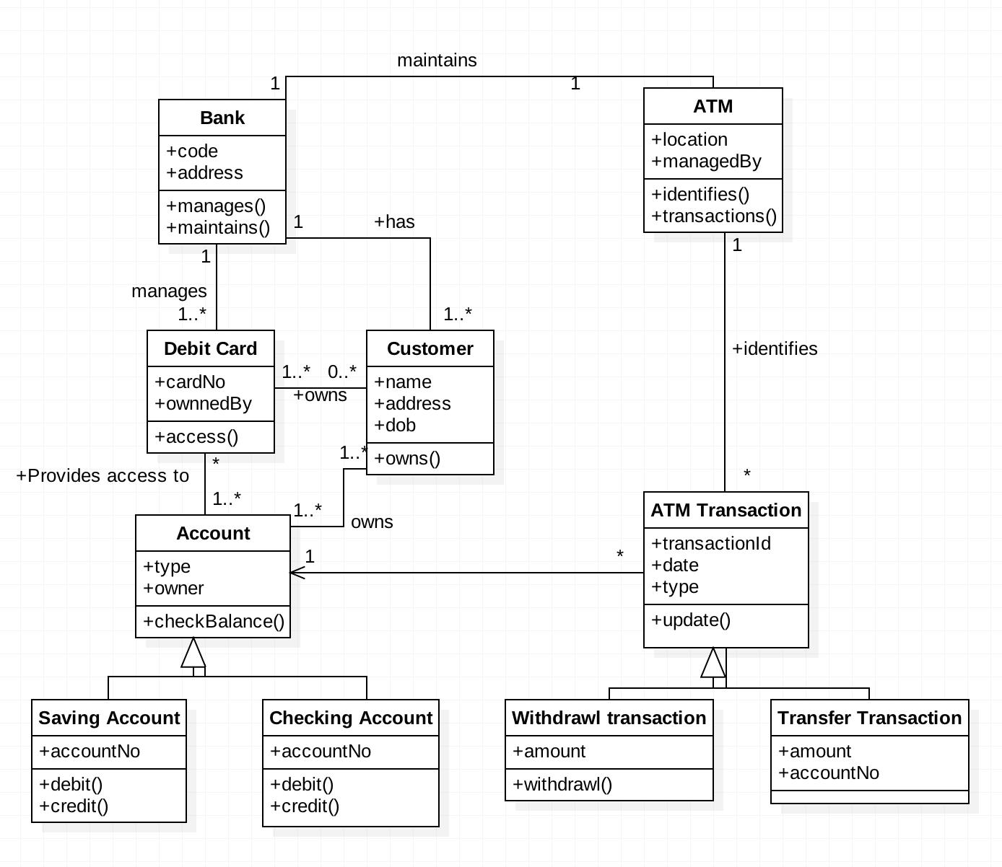
For Function: Use case, Sequence, Collaboration/Communication

- Aim: Use Case Diagram for Atm
Use case diagrams describe the functionality of a system and users of the system. They contain the following elements:
- Actors, which represent users of a system, including human users and other systems
- Use cases, which represent functionality or services provided by a system to users

Here, is a use case diagram for the ATM System.
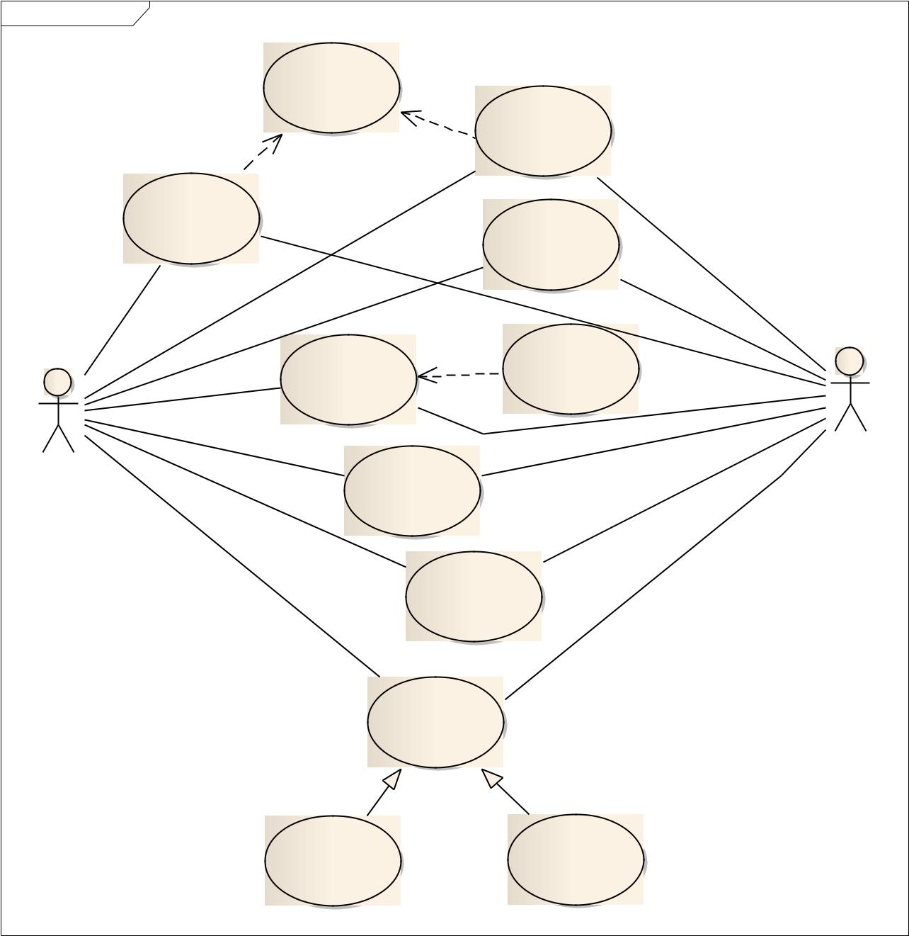

uc Use Case Model

Check Exceeding

Balance

«include» | Withdraw Cash

«include»

Transfer Money

 | Check balance
Log Out | Print Receipt
Log Out | «extend»

Bank

Customer

Deposit a Check

Deposit Cash

Log in

Depit Card Login Credit Card Login
- Aim: Sequence Diagram for Atm
Sequence diagrams typically show the flow of functionality through a use case, and consist of the following components:
- Actors , involved in the functionality
- Objects , that a system needs to provide the functionality
- Messages , which represent communication between objects

Here, is an example of Sequence diagram for withdrawing amount from ATM.
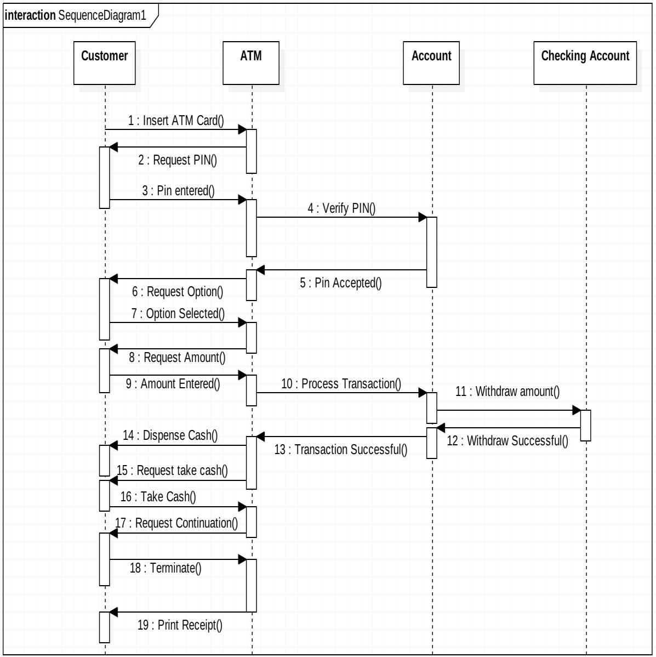
- Aim: Communication/Collaboration Diagrams for Atm

A Communication or Collaboration diagram, as shown is a directed graph that uses objects and actors as graph nodes. The focus of the collaboration diagram is on the roles of the objects as they interact to realize a system function. Directional links are used to indicate communication between objects. These links are labeled using appropriate messages. Each message is prefixed with a sequence number indicating the time ordering needed to realize the system function.

Here is an example of the Check Balance communication diagram:
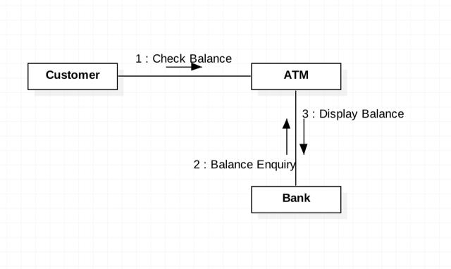

Here is an example of the Deposit Cash communication diagram:
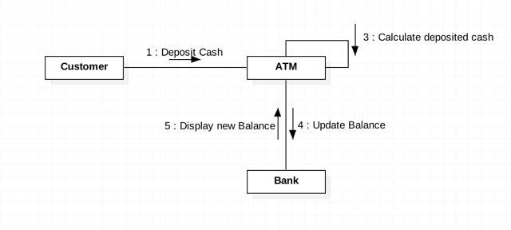
For behavior: State, Activity Diagram

- Aim: State Diagram for Atm
State transition diagrams provide a way to model the various states in which an object can exist. While the class diagram show a static picture of the classes and their relationships, state transition diagrams model the dynamic behavior of a systen in response to external events (stimuli). State transition diagrams consist of the following:

  - States, which show the possible situations in which an object can find itself

- Transitions, which show the different events which cause a change in the state of an object.

Here, is an example of the state diagram for the session of ATM.
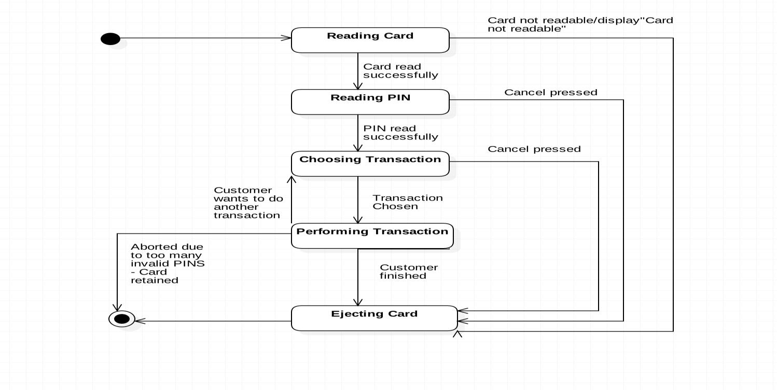

- Aim: Activity Diagram for Atm
Activity diagrams describe the activities of a class. They are similar to state transition diagrams and use similar conventions, but activity diagrams describe the behavior/states of a class in response to internal processing rather than external events. They contain the following elements:

- Swimlanes, which delegate specific actions to objects within an overall activity

- Action States, which represent uninterruptible actions of entities, or steps in the execution of an algorithm

- Action Flows, which represent relationships between the different action states on an entity

- Object Flows, which represent utilization of objects by action states, or influence of action states on objects.

Following are the examples of Login, Withdraw Activity Diagrams.
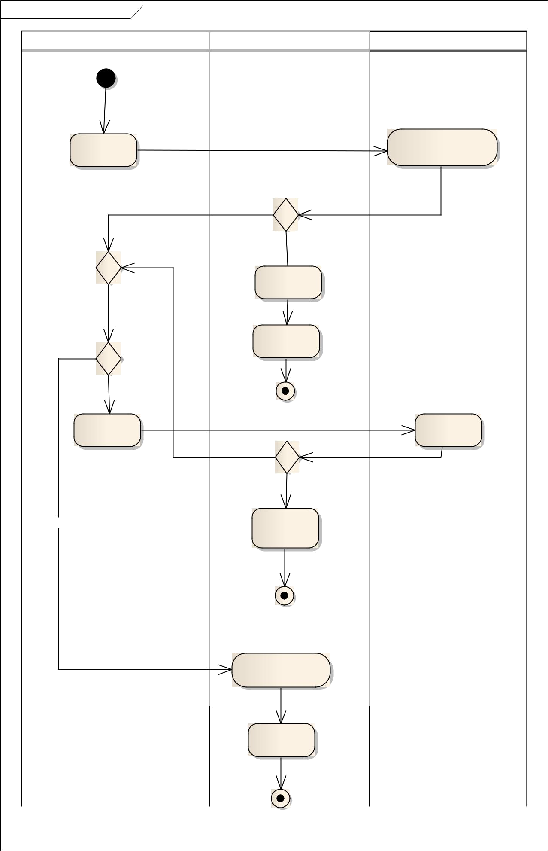
act LogIn Activ ity Diagram

Customer | ATM | Bank
ActivityInitial
Insert Card |  | Authorize Card
 | Ok?
[Yes]
 | [No]
 | Display Error
 | Msg
Max Num Tries? | Ej ect Card
 | [No]
[No] | ActivityFinal
Inser Pin |  | Authorize
Inser Pin |  | PIN
 | PIN is correct? | PIN
 | [Yes]
[Yes] | Display
[Yes] | Transactions
 | List

ActivityFinal

Lock Card

Display Error

ActivityFinal
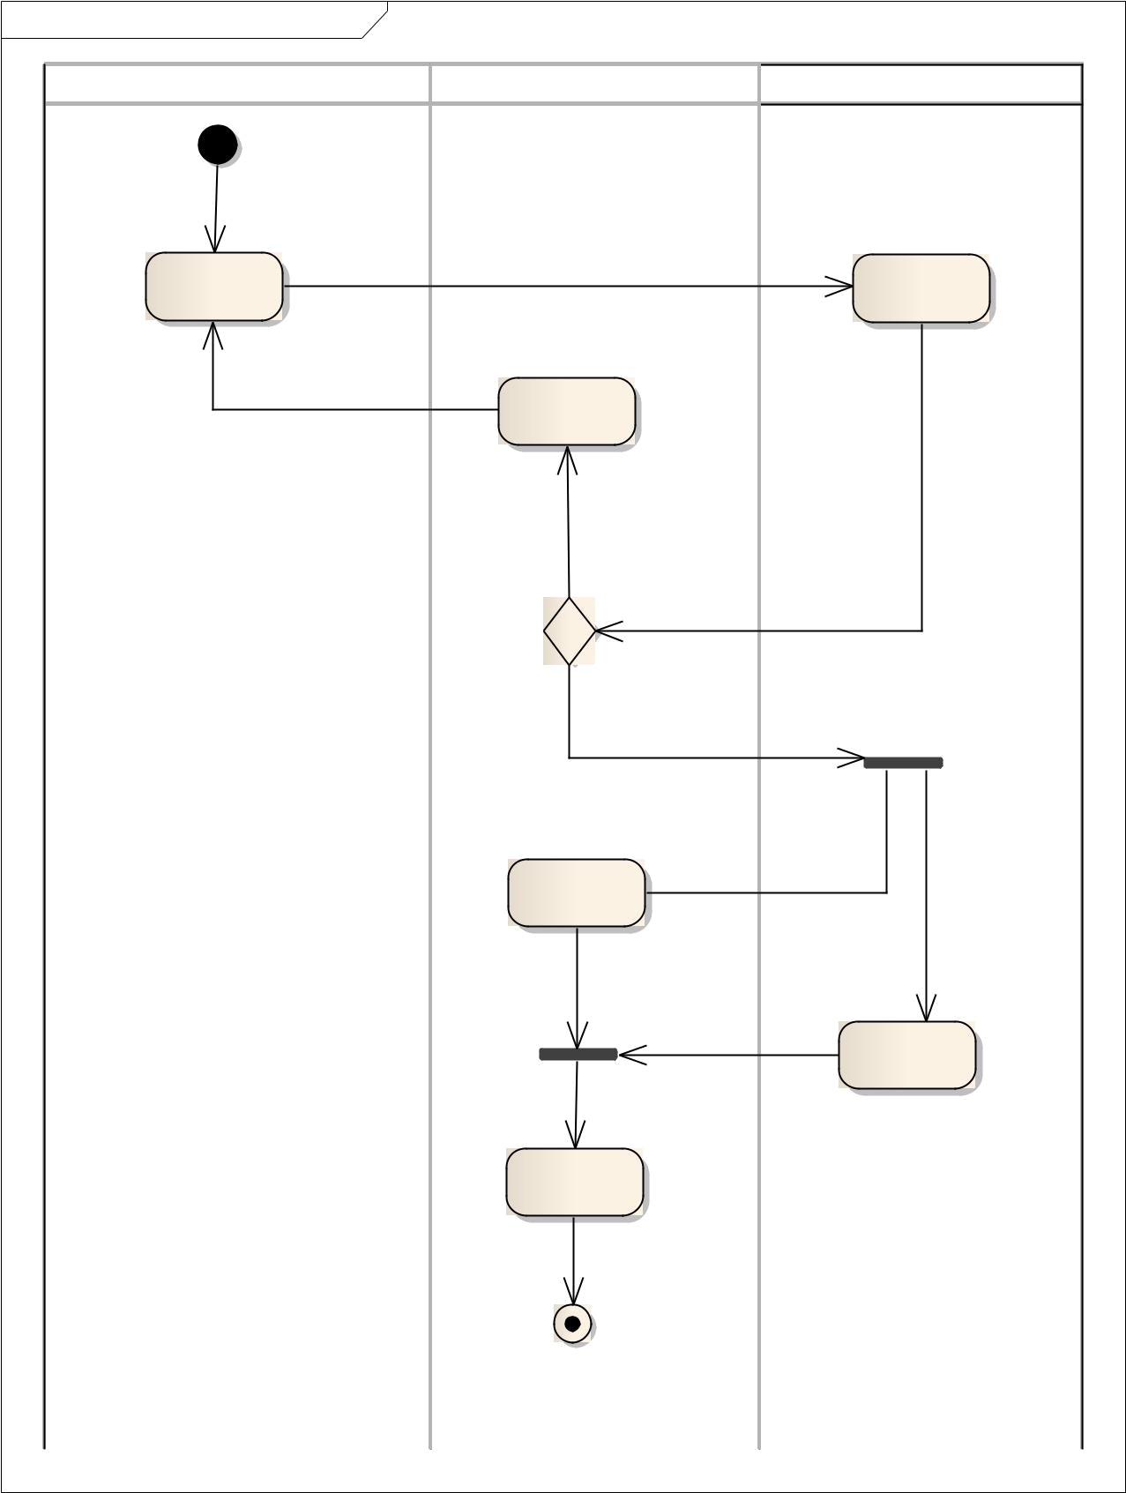
act Withdraw Cash Activ ity Diagram

Customer | ATM | Bank
ActivityInitial
Inser |  | Amount <=
Amount |  | Balance
 | Display
 | Balance

[No]

Ok?

[Yes]

Ej ect Money

Update

Balance

Display New

Balance

ActivityFinal

- Aim: Component Diagram for Atm
Component diagrams are used to visualize the organization and relationships among components in a system. These diagrams are also used to make executable systems.
The purpose of the component diagram can be summarized as −
- Visualize the components of a system.
- Construct executables by using forward and reverse engineering.
- Describe the organization and relationships of the components.

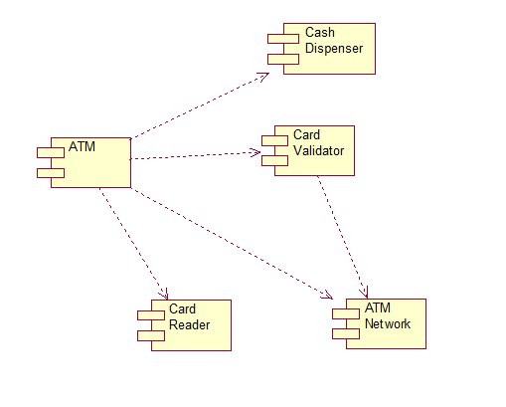

- Aim: Deployment Diagram for Atm
Deployment diagrams are used for describing the hardware components, where software components are deployed. Component diagrams and deployment diagrams are closely related.
The purpose of deployment diagrams can be described as −
- Visualize the hardware topology of a system.
- Describe the hardware components used to deploy software components.
- Describe the runtime processing nodes.

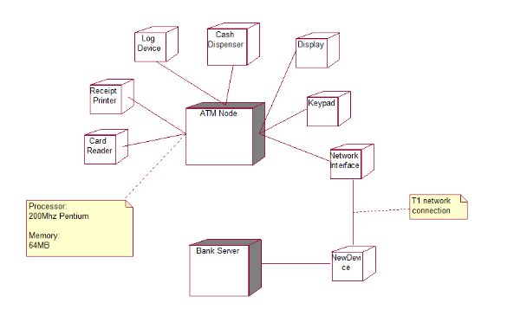

Result: The Design was successfully completed.

